Archana Balachandran

MS CIS

Instructor: Prof. Suresh Kalathur

Analysis of world university ranking dataset

CS544 Foundations of Analytics

## Data Preparation

1. **Dataset Download**

The dataset World University Ranking was downloaded from Kaggle. The data selected is based on Shanghai Ranking, which is a powerful ranking method considering the important university measures for rank determination. The dataset was downloaded and viewed in Excel.

From the dataset containing a total of 4897 entries for rankings from 2005-2015, the top 100 universities in the year 2012 were selected.

Some of the relevant columns in the dataset is described below[1]:

* world_rank - world rank for university. Contains rank ranges and equal ranks (eg. 101-152).
* university_name - name of university.
* national_rank - rank of university within its country.
* score - total score, used to determine rank.
* alumni - Alumni Score, based on the number of alumni of an institution winning nobel prizes and fields medals.
* award - Award Score, based on the number of staff of an institution winning Nobel Prizes in Physics, Chemistry, Medicine, and Economics and Fields Medals in Mathematics.
* year - year of ranking (2012).

1. **Conversion to CSV format**

File -> Save As -> Select CSV in Type

1. **Dataset Import**

RStudio -> Tools -> Import Dataset -> From Local file

To view the imported dataset in R.

View(UniRanking)

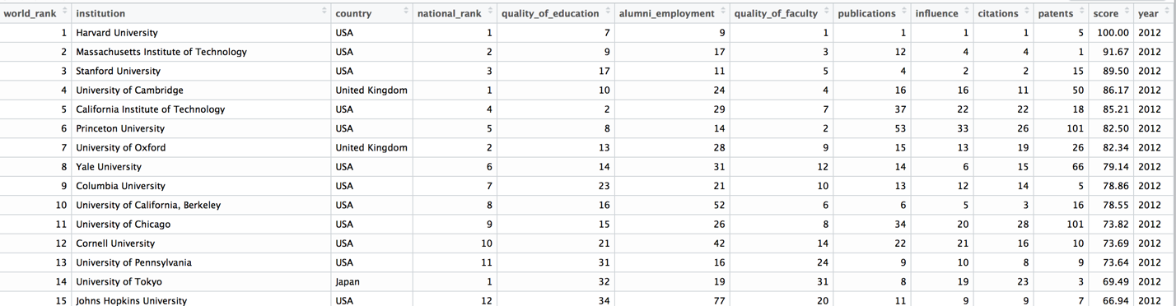

## Analysis of Categorical Data

**All columns in the dataset:**

|  |
| --- |
| world_rank |
| institution |
| country |
| national_rank |
| quality_of_education |
| alumni_employment |
| quality_of_faculty |
| publications |
| influence |
| citations |
| patents |
| score |
| Year |

The column ‘country’ can be selected for categorical analysis, where the number of colleges in each country(which is the frequency) can be identified.

country.data<-UniRanking$country

table(UniRanking$country)

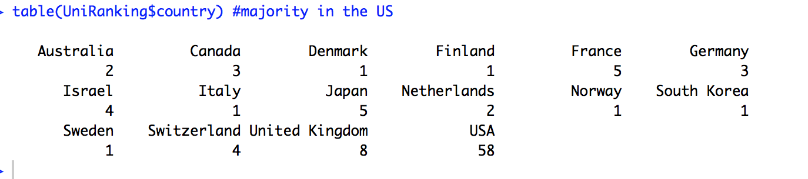

The countries having atleast 1 top university are USA, United Kingdon, Switzerland, Sweden, South Korea, Norway, Netherlands, Japan, Italy, Israel, Germany, France, Finland, Denmark, Canada and Australia.

As one can observe, USA has the maximum number of top colleges, followed by United Kingdom. Japan and France both share the next position with 5 top universities in each country.

## Analysis of Numerical Data

The score for each university can be used as a measure for numerical data analysis.

dotchart(UniRanking$score, col="red3", xlab="Score", main="Aggregation of Scores")



It can be observed that the scores primarily cluster around the rand 40 – 50, and is more spread out after 68. It may indicate that very few universities fall within the top 30%.

As observed earlier, a barplot of the countries rankings would indicate that USA has the largest number of top-ranked universities in the world.

barplot(table(UniRanking$country),ylim = c(0,60), las=2,main="Country-wise ranking")



We will now take a good look at USA, since it has the majority of top-ranked universities –We will examine score in all top-ranked US universities.

usa.score <- subset(UniRanking, country=="USA", select=(c("score")))





A boxplot can be considered more accurate in displaying the center, spread and skew of scores data. We can also note the outliers in the scores data.





Comparing Scores in Top three countries (countries having highest number of top-ranked universities):

USA(58 top universities) UK(8 top universities) and France(5 top universities) are taken for this comparative study.





UK and USA both have a very similar median (around 52), which indicates that 50% of the data is greater than this value. No outliers are observed in the case of UK, whereas, outliers are observed for USA and France. 5 outliers are observed in USA, which indicates the top 5 colleges in USA with 5 highest scores.

In the case of France which has 5 records, University of Helsinki(having a score of 44) is the outlier in the lower section of data, while University of Paris-Sud is another outlier in the upper end, having a score of 50.44. The minimum, median and lower quartile appears to be the same.

## Distribution of Scores





**Comparing Scores across countries**

The impact of standard deviation on the shape of the curve can be observed in the distributions shown below(ignore outliers). As the standard deviation decreases, shape of curve becomes teeper.

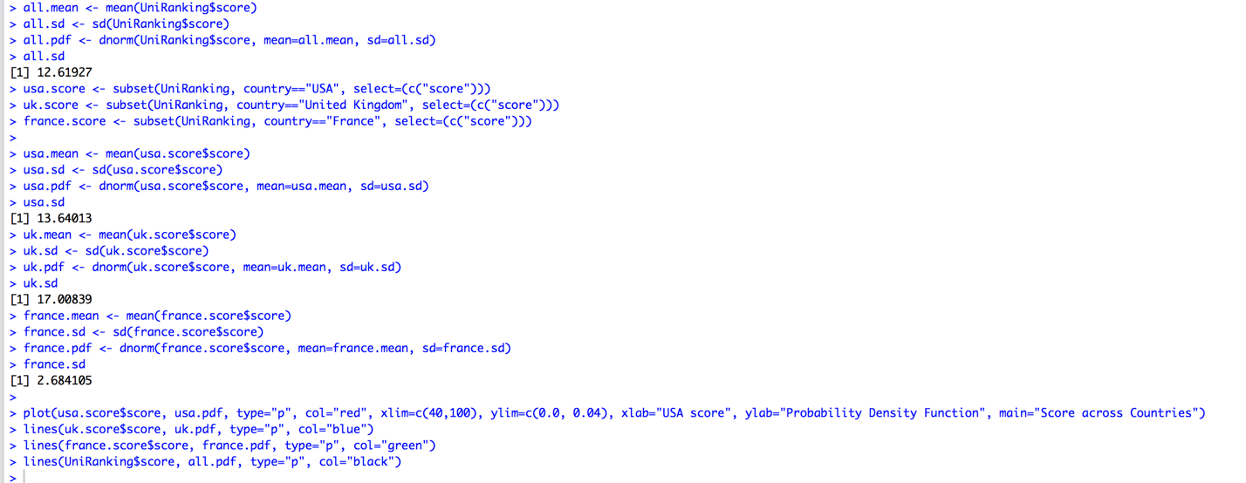



Standard Deviation in decreasing order: UK(blue)>US(red)>All(black)>France (green)

It is observed that, as the SD decreases, the shape of the curve becomes steeper.

## Central Limit Theorem: Application

## Sampling with Normal Distribution Data

From the plots below, it can be observed that, as the sample size increases, the standard deviation of the scores of US universities decreases while the mean remains a constant.

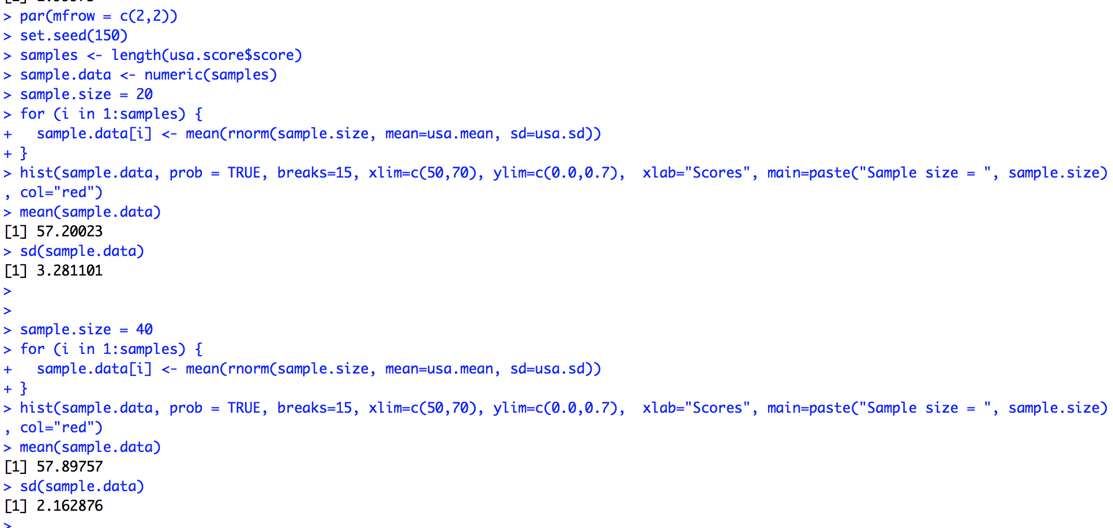

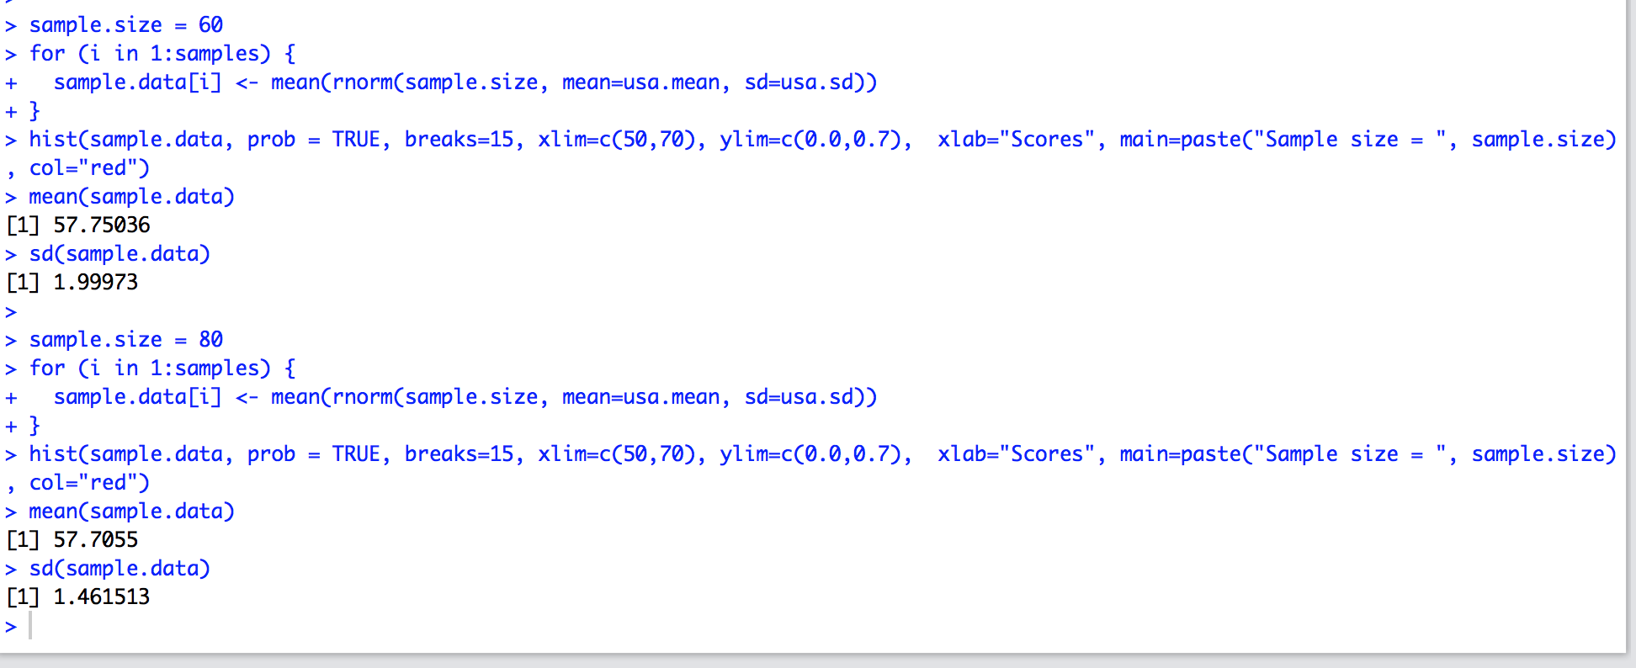



## Sampling Methods

The following sampling methods are explored in the sections below:

1. Simple Random Sampling with Replacement
2. Simple Random Sampling without Replacement
3. Systematic Sampling

## Simple Random Sampling With Replacement

All items in the data frame has the same probability for selection. For the UniRanking dataset, a sample of size 40 was selected using Simple Random Sampling with Replacement.

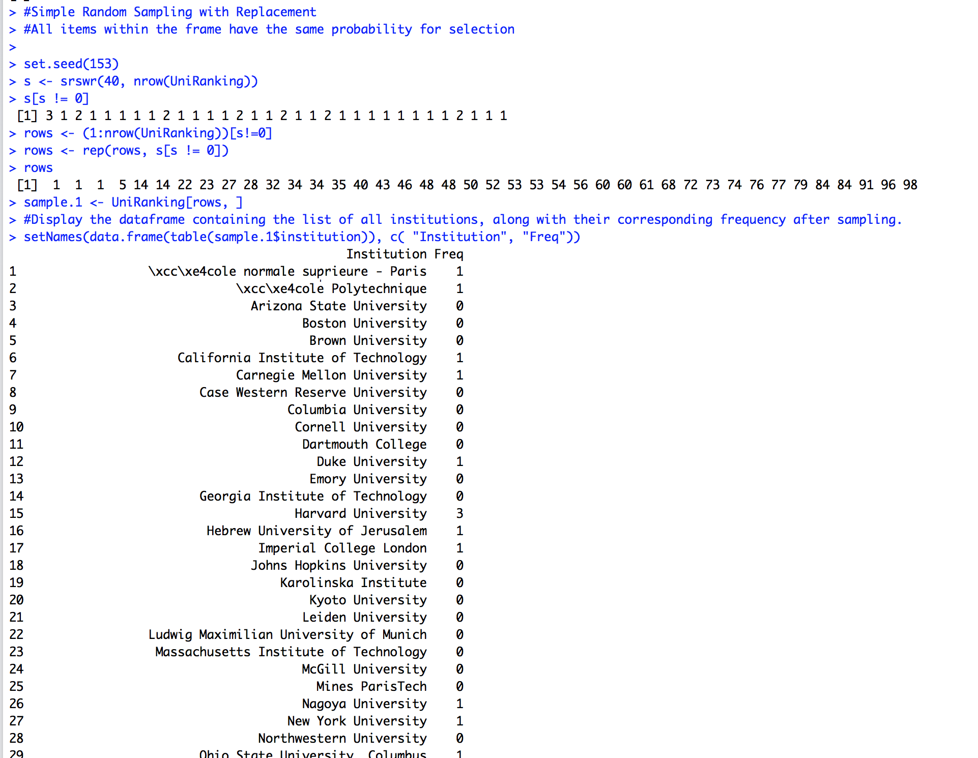

Institution Freq

1 \xcc\xe4cole normale sup̩rieure - Paris 1

2 \xcc\xe4cole Polytechnique 1

3 Arizona State University 0

4 Boston University 0

5 Brown University 0

6 California Institute of Technology 1

7 Carnegie Mellon University 1

8 Case Western Reserve University 0

9 Columbia University 0

10 Cornell University 0

11 Dartmouth College 0

12 Duke University 1

13 Emory University 0

14 Georgia Institute of Technology 0

15 Harvard University 3

16 Hebrew University of Jerusalem 1

17 Imperial College London 1

18 Johns Hopkins University 0

19 Karolinska Institute 0

20 Kyoto University 0

21 Leiden University 0

22 Ludwig Maximilian University of Munich 0

23 Massachusetts Institute of Technology 0

24 McGill University 0

25 Mines ParisTech 0

26 Nagoya University 1

27 New York University 1

28 Northwestern University 0

29 Ohio State University, Columbus 1

30 Osaka University 1

31 Pennsylvania State University, University Park 0

32 Pierre-and-Marie-Curie University 0

33 Princeton University 0

34 Purdue University, West Lafayette 0

35 Rice University 0

36 Rockefeller University 0

37 Ruprecht Karl University of Heidelberg 0

38 Rutgers University-New Brunswick 1

39 Sapienza University of Rome 1

40 Seoul National University 0

41 Stanford University 0

42 Swiss Federal Institute of Technology in Lausanne 0

43 Swiss Federal Institute of Technology in Zurich 0

44 Technical University of Munich 0

45 Technion \x89\xdb\xd2 Israel Institute of Technology 0

46 Tel Aviv University 1

47 Texas A&M University, College Station 1

48 Tohoku University 1

49 Tufts University 0

50 University College London 0

51 University of Arizona 1

52 University of Bristol 1

53 University of British Columbia 0

54 University of California, Berkeley 0

55 University of California, Davis 0

56 University of California, Irvine 0

57 University of California, Los Angeles 0

58 University of California, San Diego 0

59 University of California, San Francisco 0

60 University of California, Santa Barbara 1

61 University of Cambridge 0

62 University of Chicago 0

63 University of Colorado Boulder 1

64 University of Copenhagen 0

65 University of Edinburgh 2

66 University of Florida 0

67 University of Geneva 0

68 University of Helsinki 0

69 University of Illinois at Urbana\x89\xdb\xd2Champaign 0

70 University of Manchester 1

71 University of Maryland, College Park 1

72 University of Michigan, Ann Arbor 2

73 University of Minnesota, Twin Cities 0

74 University of North Carolina at Chapel Hill 0

75 University of Nottingham 0

76 University of Oslo 1

77 University of Oxford 0

78 University of Paris-Sud 2

79 University of Pennsylvania 0

80 University of Pittsburgh - Pittsburgh Campus 0

81 University of Queensland 0

82 University of Rochester 2

83 University of Southern California 0

84 University of Sydney 0

85 University of Texas at Austin 0

86 University of Texas MD Anderson Cancer Center 1

87 University of Texas Southwestern Medical Center 0

88 University of Tokyo 2

89 University of Toronto 1

90 University of Utah 0

91 University of Virginia 2

92 University of Washington - Seattle 0

93 University of Wisconsin\x89\xdb\xd2Madison 0

94 University of Zurich 0

95 Utrecht University 0

96 Vanderbilt University 0

97 Washington University in St. Louis 0

98 Weizmann Institute of Science 0

99 Williams College 0

1. Yale University 0

## Simple Random sampling without Replacement

A simple random sample of size 40 was drawn from the UniRanking dataset (which has 100 rows) without replacement.

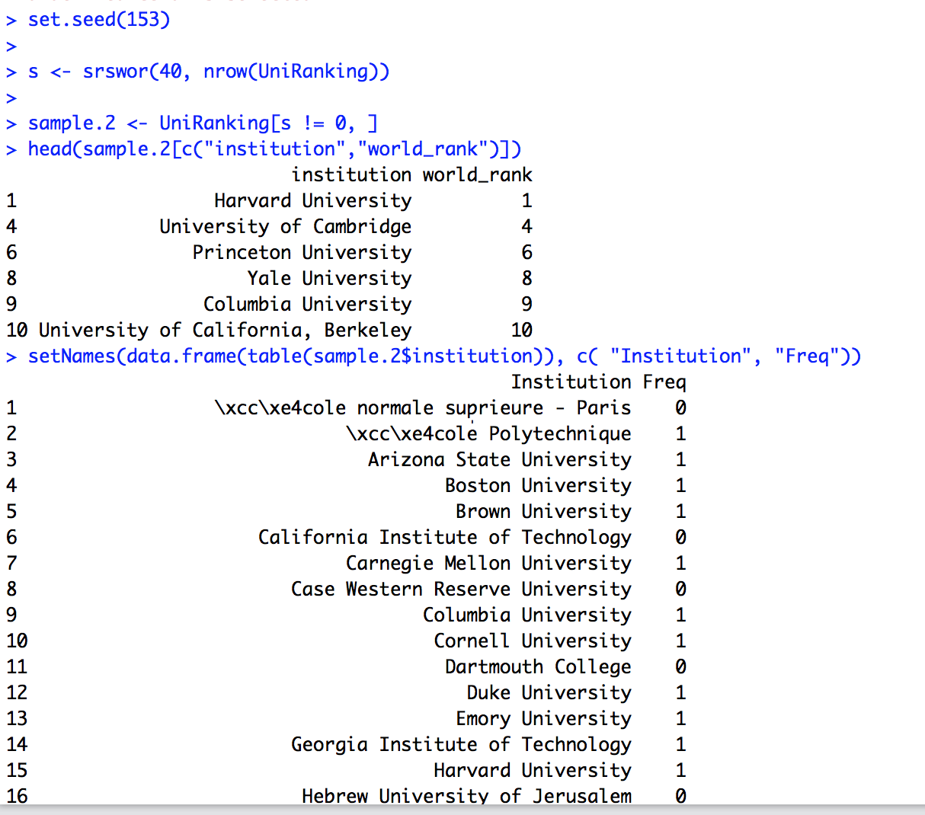

Institution Freq

1 \xcc\xe4cole normale sup̩rieure - Paris 0

2 \xcc\xe4cole Polytechnique 1

3 Arizona State University 1

4 Boston University 1

5 Brown University 1

6 California Institute of Technology 0

7 Carnegie Mellon University 1

8 Case Western Reserve University 0

9 Columbia University 1

10 Cornell University 1

11 Dartmouth College 0

12 Duke University 1

13 Emory University 1

14 Georgia Institute of Technology 1

15 Harvard University 1

16 Hebrew University of Jerusalem 0

17 Imperial College London 0

18 Johns Hopkins University 0

19 Karolinska Institute 0

20 Kyoto University 0

21 Leiden University 1

22 Ludwig Maximilian University of Munich 0

23 Massachusetts Institute of Technology 0

24 McGill University 0

25 Mines ParisTech 1

26 Nagoya University 0

27 New York University 0

28 Northwestern University 0

29 Ohio State University, Columbus 0

30 Osaka University 0

31 Pennsylvania State University, University Park 1

32 Pierre-and-Marie-Curie University 0

33 Princeton University 1

34 Purdue University, West Lafayette 1

35 Rice University 0

36 Rockefeller University 0

37 Ruprecht Karl University of Heidelberg 0

38 Rutgers University-New Brunswick 1

39 Sapienza University of Rome 0

40 Seoul National University 0

41 Stanford University 0

42 Swiss Federal Institute of Technology in Lausanne 0

43 Swiss Federal Institute of Technology in Zurich 0

44 Technical University of Munich 0

45 Technion \x89\xdb\xd2 Israel Institute of Technology 1

46 Tel Aviv University 0

47 Texas A&M University, College Station 0

48 Tohoku University 1

49 Tufts University 0

50 University College London 1

51 University of Arizona 1

52 University of Bristol 0

53 University of British Columbia 0

54 University of California, Berkeley 1

55 University of California, Davis 0

56 University of California, Irvine 1

57 University of California, Los Angeles 1

58 University of California, San Diego 0

59 University of California, San Francisco 0

60 University of California, Santa Barbara 0

61 University of Cambridge 1

62 University of Chicago 1

63 University of Colorado Boulder 0

64 University of Copenhagen 0

65 University of Edinburgh 0

66 University of Florida 0

67 University of Geneva 0

68 University of Helsinki 0

69 University of Illinois at Urbana\x89\xdb\xd2Champaign 0

70 University of Manchester 0

71 University of Maryland, College Park 0

72 University of Michigan, Ann Arbor 1

73 University of Minnesota, Twin Cities 0

74 University of North Carolina at Chapel Hill 0

75 University of Nottingham 0

76 University of Oslo 0

77 University of Oxford 0

78 University of Paris-Sud 0

79 University of Pennsylvania 0

80 University of Pittsburgh - Pittsburgh Campus 1

81 University of Queensland 0

82 University of Rochester 0

83 University of Southern California 1

84 University of Sydney 1

85 University of Texas at Austin 1

86 University of Texas MD Anderson Cancer Center 1

87 University of Texas Southwestern Medical Center 0

88 University of Tokyo 1

89 University of Toronto 0

90 University of Utah 0

91 University of Virginia 1

92 University of Washington - Seattle 0

93 University of Wisconsin\x89\xdb\xd2Madison 1

94 University of Zurich 0

95 Utrecht University 1

96 Vanderbilt University 0

97 Washington University in St. Louis 1

98 Weizmann Institute of Science 1

99 Williams College 1

100 Yale University 1

## Systematic Sampling

For a sample size n, N items from the frame are partitioned into n groups. Each group has k items (K=N/n). First item for the sample is randomly selected from the first set of k items in the frame. After the first selection, remaining n-1 items are selected by taking every kth item from the frame. [2]

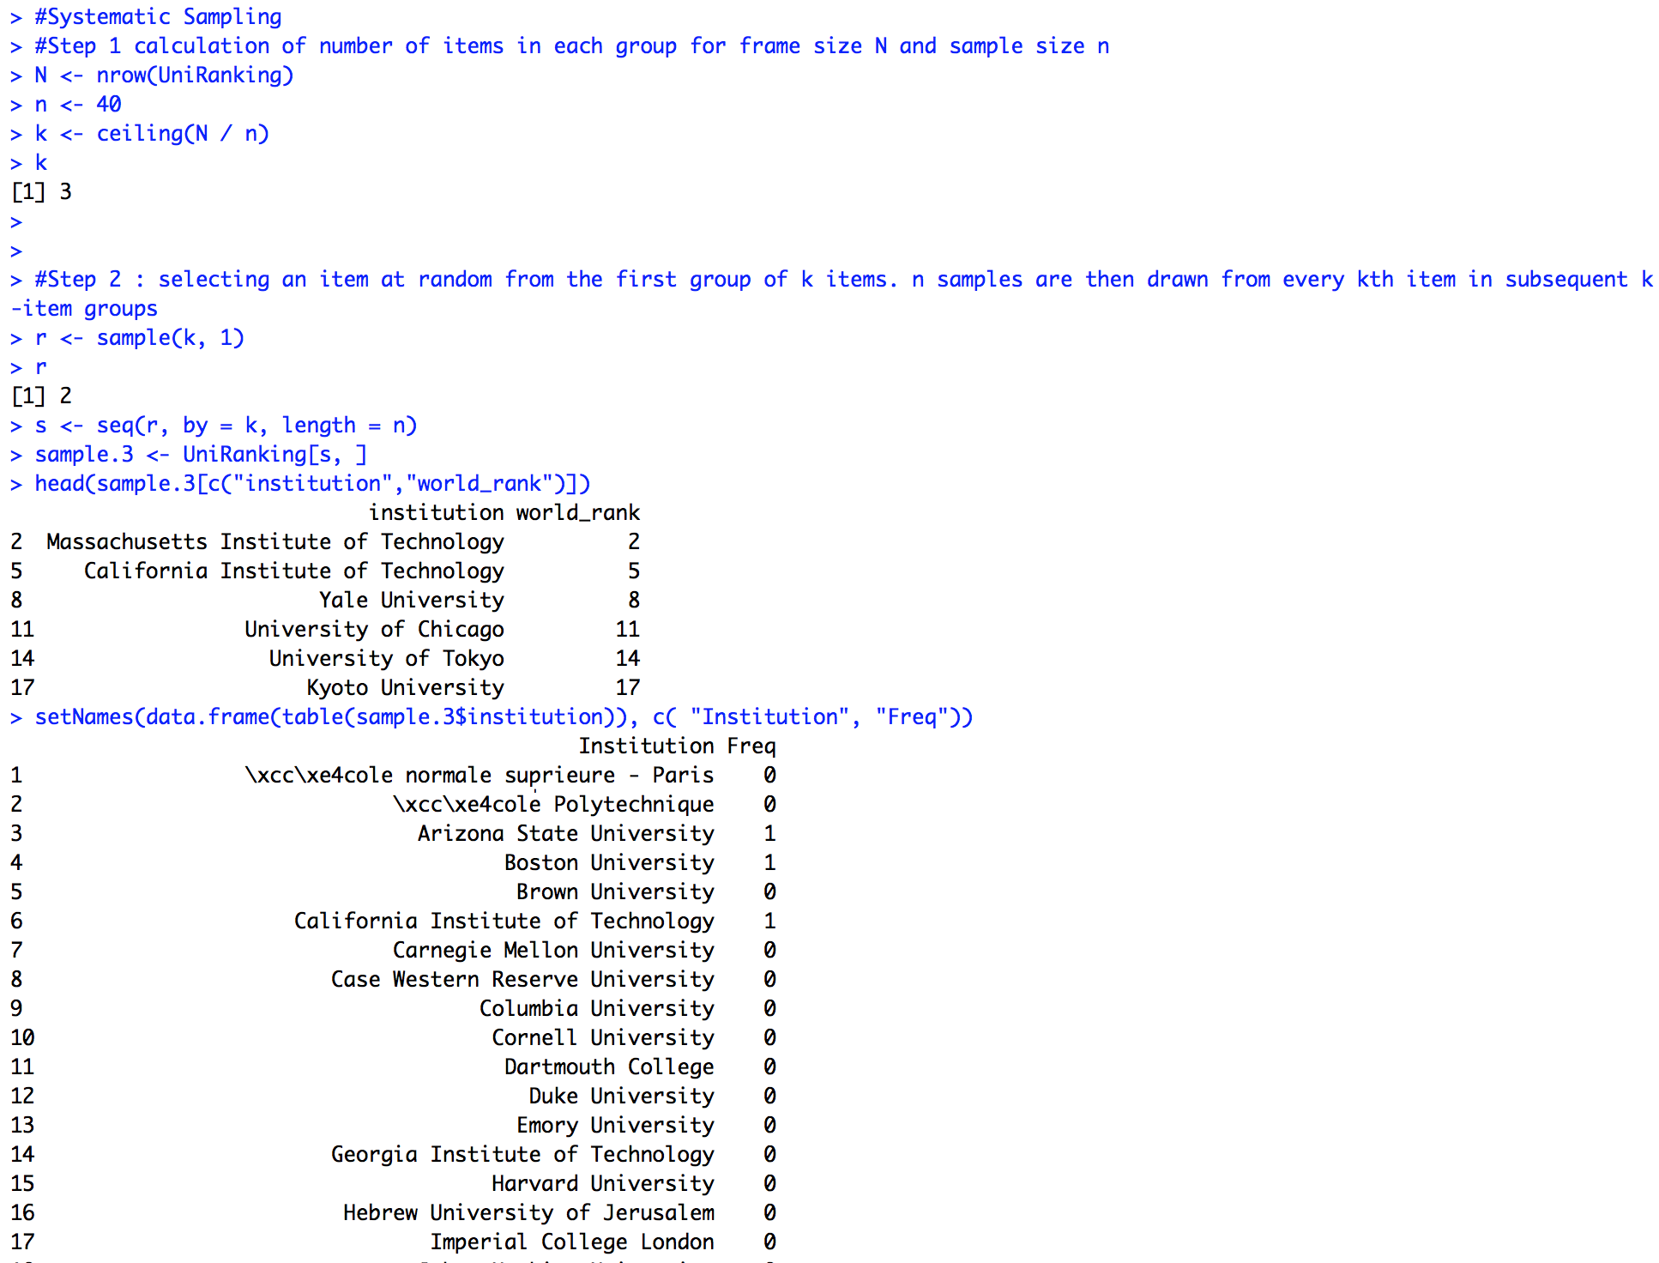

## Confidence Level – 80%

We will now show the confidence intervals of the mean of numeric variable for various samples and compare against the population mean. The variable selected for this section is scores, and the number of samples drawn is 50(for both ci=80% and 90%).

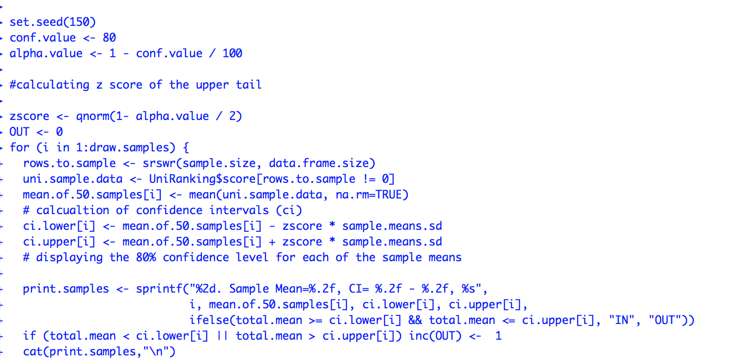

**Mean of population:**

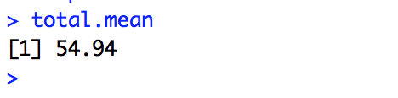

1. Sample Mean=55.54, CI= 53.92 - 57.15, IN

2. Sample Mean=54.07, CI= 52.45 - 55.68, IN

3. Sample Mean=55.50, CI= 53.89 - 57.12, IN

4. Sample Mean=54.42, CI= 52.80 - 56.04, IN

5. Sample Mean=54.32, CI= 52.70 - 55.94, IN

6. Sample Mean=56.54, CI= 54.92 - 58.15, IN

7. Sample Mean=53.82, CI= 52.21 - 55.44, IN

8. Sample Mean=55.96, CI= 54.34 - 57.58, IN

9. Sample Mean=55.46, CI= 53.84 - 57.08, IN

10. Sample Mean=53.95, CI= 52.33 - 55.57, IN

11. Sample Mean=55.10, CI= 53.49 - 56.72, IN

12. Sample Mean=54.05, CI= 52.43 - 55.66, IN

13. Sample Mean=55.77, CI= 54.15 - 57.38, IN

14. Sample Mean=55.13, CI= 53.51 - 56.74, IN

15. Sample Mean=53.99, CI= 52.37 - 55.61, IN

16. Sample Mean=54.19, CI= 52.57 - 55.81, IN

17. Sample Mean=56.38, CI= 54.77 - 58.00, IN

18. Sample Mean=54.46, CI= 52.84 - 56.08, IN

19. Sample Mean=53.86, CI= 52.24 - 55.48, IN

20. Sample Mean=53.02, CI= 51.40 - 54.64, OUT

21. Sample Mean=55.84, CI= 54.23 - 57.46, IN

22. Sample Mean=55.32, CI= 53.70 - 56.94, IN

23. Sample Mean=54.18, CI= 52.57 - 55.80, IN

24. Sample Mean=54.76, CI= 53.14 - 56.37, IN

25. Sample Mean=56.44, CI= 54.83 - 58.06, IN

26. Sample Mean=54.25, CI= 52.63 - 55.87, IN

27. Sample Mean=55.36, CI= 53.75 - 56.98, IN

28. Sample Mean=55.45, CI= 53.84 - 57.07, IN

29. Sample Mean=56.92, CI= 55.30 - 58.53, OUT

30. Sample Mean=55.37, CI= 53.75 - 56.99, IN

31. Sample Mean=55.72, CI= 54.10 - 57.33, IN

32. Sample Mean=54.63, CI= 53.01 - 56.24, IN

33. Sample Mean=56.29, CI= 54.67 - 57.91, IN

34. Sample Mean=54.24, CI= 52.62 - 55.86, IN

35. Sample Mean=54.23, CI= 52.61 - 55.85, IN

36. Sample Mean=55.44, CI= 53.82 - 57.06, IN

37. Sample Mean=56.85, CI= 55.23 - 58.46, OUT

38. Sample Mean=56.01, CI= 54.39 - 57.62, IN

39. Sample Mean=55.70, CI= 54.09 - 57.32, IN

40. Sample Mean=55.38, CI= 53.77 - 57.00, IN

41. Sample Mean=54.61, CI= 52.99 - 56.22, IN

42. Sample Mean=55.57, CI= 53.95 - 57.19, IN

43. Sample Mean=55.13, CI= 53.51 - 56.75, IN

44. Sample Mean=55.28, CI= 53.66 - 56.90, IN

45. Sample Mean=54.80, CI= 53.18 - 56.41, IN

46. Sample Mean=55.62, CI= 54.00 - 57.24, IN

47. Sample Mean=53.80, CI= 52.19 - 55.42, IN

48. Sample Mean=53.82, CI= 52.20 - 55.43, IN

49. Sample Mean=56.61, CI= 54.99 - 58.22, OUT

50. Sample Mean=55.77, CI= 54.15 - 57.39, IN

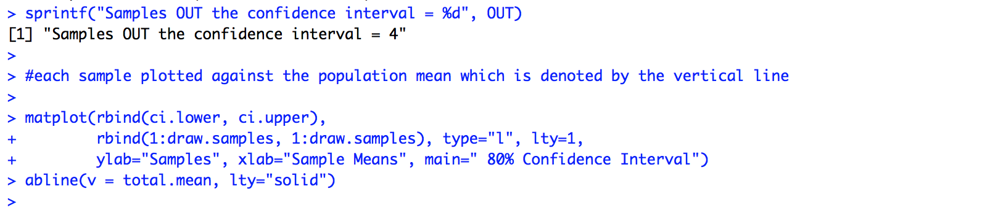



## Confidence Level – 90%

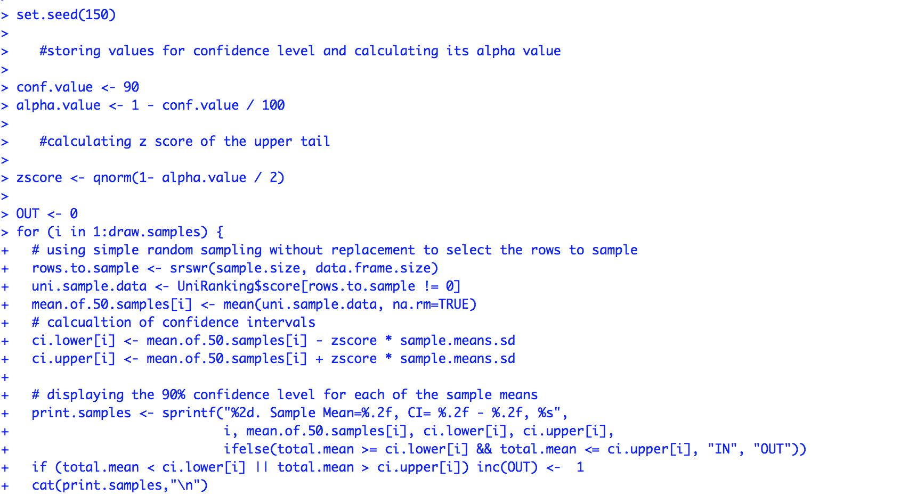

**Mean of population:**



1. Sample Mean=55.54, CI= 53.46 - 57.61, IN

2. Sample Mean=54.07, CI= 51.99 - 56.14, IN

3. Sample Mean=55.50, CI= 53.43 - 57.58, IN

4. Sample Mean=54.42, CI= 52.34 - 56.50, IN

5. Sample Mean=54.32, CI= 52.24 - 56.39, IN

6. Sample Mean=56.54, CI= 54.46 - 58.61, IN

7. Sample Mean=53.82, CI= 51.75 - 55.90, IN

8. Sample Mean=55.96, CI= 53.89 - 58.04, IN

9. Sample Mean=55.46, CI= 53.38 - 57.54, IN

10. Sample Mean=53.95, CI= 51.87 - 56.03, IN

11. Sample Mean=55.10, CI= 53.03 - 57.18, IN

12. Sample Mean=54.05, CI= 51.97 - 56.12, IN

13. Sample Mean=55.77, CI= 53.69 - 57.84, IN

14. Sample Mean=55.13, CI= 53.05 - 57.20, IN

15. Sample Mean=53.99, CI= 51.91 - 56.07, IN

16. Sample Mean=54.19, CI= 52.11 - 56.26, IN

17. Sample Mean=56.38, CI= 54.31 - 58.46, IN

18. Sample Mean=54.46, CI= 52.38 - 56.54, IN

19. Sample Mean=53.86, CI= 51.78 - 55.93, IN

20. Sample Mean=53.02, CI= 50.95 - 55.10, IN

21. Sample Mean=55.84, CI= 53.77 - 57.92, IN

22. Sample Mean=55.32, CI= 53.24 - 57.39, IN

23. Sample Mean=54.18, CI= 52.11 - 56.26, IN

24. Sample Mean=54.76, CI= 52.68 - 56.83, IN

25. Sample Mean=56.44, CI= 54.37 - 58.52, IN

26. Sample Mean=54.25, CI= 52.18 - 56.33, IN

27. Sample Mean=55.36, CI= 53.29 - 57.44, IN

28. Sample Mean=55.45, CI= 53.38 - 57.53, IN

29. Sample Mean=56.92, CI= 54.84 - 58.99, IN

30. Sample Mean=55.37, CI= 53.30 - 57.45, IN

31. Sample Mean=55.72, CI= 53.64 - 57.79, IN

32. Sample Mean=54.63, CI= 52.55 - 56.70, IN

33. Sample Mean=56.29, CI= 54.21 - 58.36, IN

34. Sample Mean=54.24, CI= 52.16 - 56.31, IN

35. Sample Mean=54.23, CI= 52.16 - 56.31, IN

36. Sample Mean=55.44, CI= 53.36 - 57.51, IN

37. Sample Mean=56.85, CI= 54.77 - 58.92, IN

38. Sample Mean=56.01, CI= 53.93 - 58.08, IN

39. Sample Mean=55.70, CI= 53.63 - 57.78, IN

40. Sample Mean=55.38, CI= 53.31 - 57.46, IN

41. Sample Mean=54.61, CI= 52.53 - 56.68, IN

42. Sample Mean=55.57, CI= 53.50 - 57.65, IN

43. Sample Mean=55.13, CI= 53.05 - 57.20, IN

44. Sample Mean=55.28, CI= 53.21 - 57.36, IN

45. Sample Mean=54.80, CI= 52.72 - 56.87, IN

46. Sample Mean=55.62, CI= 53.54 - 57.69, IN

47. Sample Mean=53.80, CI= 51.73 - 55.88, IN

48. Sample Mean=53.82, CI= 51.74 - 55.89, IN

49. Sample Mean=56.61, CI= 54.53 - 58.68, IN

50. Sample Mean=55.77, CI= 53.69 - 57.84, IN

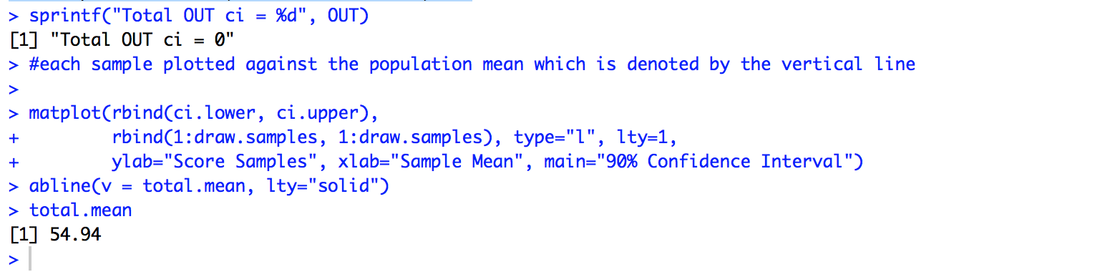



**Observations:**

When confidence level is 80%, the sample confidence intervals that contain the population mean is 96%. 4 samples have confidence intervals which do not contain the population mean.

When confidence level is 90%, the sample confidence intervals that contain the population mean is 100%. The confidence intervals of all samples contain the population mean.

## Reference Links:

* 1. <https://www.kaggle.com/mylesoneill/world-university-rankings>
  2. https://learn.bu.edu/bbcswebdav/pid-4255941-dt-content-rid-14691726_1/courses/16sum1metcs544sc1/CS544_Module3.pdf
  3. https://learn.bu.edu/bbcswebdav/pid-4255944-dt-content-rid-14691728_1/courses/16sum1metcs544sc1/CS544_Module4.pdf
  4. https://learn.bu.edu/bbcswebdav/pid-4255946-dt-content-rid-14691730_1/courses/16sum1metcs544sc1/CS544_Module5.pdf 3.
  5. <https://learn.bu.edu/bbcswebdav/pid-4255953-dt-content-rid-14691711_1/courses/16sum1metcs544sc1/CS544_Module6.pdf>
  6. http://www.stat.osu.edu/~calder/stat528/Lectures/lecture21_2slides.PDF

1. Source: https://www.kaggle.com/mylesoneill/world-university-rankings
2. source: https://learn.bu.edu/bbcswebdav/pid-4255946-dt-content-rid-14691730_1/courses/16sum1metcs544sc1/CS544_Module5.pdf